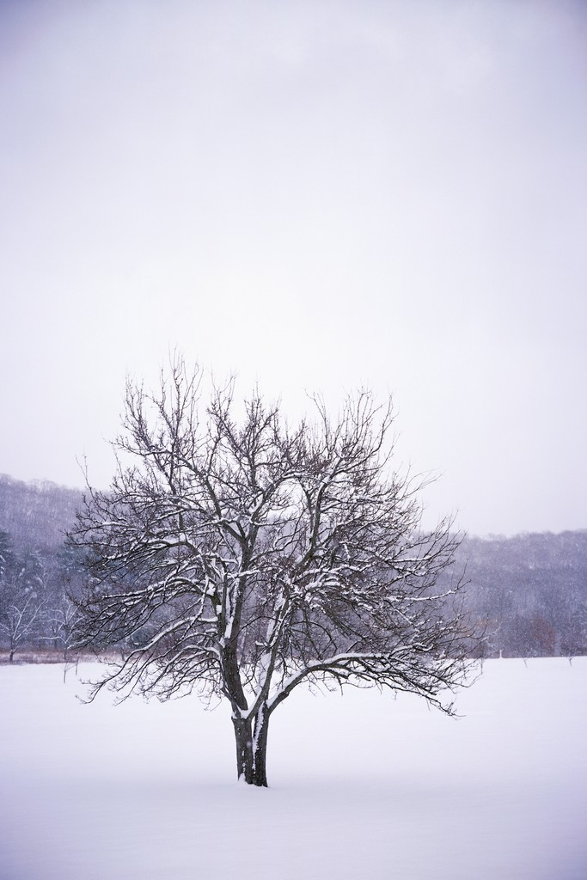

Mrs. Glaser’s Third Grade News
February 14, 2020

Dear Parents and Students,

The weather is sure wide range this week! We go from really snowy to very cold. Please remember to send winter clothes yet as it changes here in Two Rivers fast and the play ground is very wet. Boots are definitely needed along with snowpants, hats and mittens.

We had our Valentine’s Day Party on Friday. Thank you to the parents that provided treats for the class.

In math this week we continued working on our unit of time and graphs. We continue to take timed tests in multiplication and division twice a week. Super scores! Next week we will end this unit with the unit test!

Please continue to read nightly. They do have to read 20 minutes every night. Please do not let them tell you they did it at school, because they did not do it as the reading they did was assigned for reading rounds.

We have learned about the different parts of a book and how they help us when we read books that are nonfiction. We discussed table of contents, index, glossary, main headings, subheading and how they are different. We will be using these parts of books to help us write our animal reports next month.

Remember Monday February 17th there is students do not have school. Teachers have inservice.

We are working on our animal reports and discussing habitats for science. Your child will be asked to make a diorama of their animal’s habitat that will be due in a few weeks. I will be discussing this with them next week and what they have to include in the diorama.

Have a great weekend!

